**GEOLOGIC MAPPING WITH ARCGIS (outline 3.0)**

Note: The content of this workshop is partially based on workshop material created by [Roman DiBiase and Erin DiMaggio (Penn State Geosciences)](http://sites.psu.edu/dibiase/teaching/making-a-geologic-map-in-arcgis-10-x/) and a short course by [Ralph Haugerud (USGS)](https://ngmdb.usgs.gov/Info/standards/NCGMP09/).

*----------------------------------------------------------------------------------------------------------------------*

### DOWNLOAD TUTORIAL DATA

* In a browser, go to<https://stanford.box.com/SGCIntroGIS> and click on the drop-down arrow to the right of the **GeologicMapping folder** to download it in its entirety. **Save** the datasets to your **Desktop**.
* Right-click on the resulting **\*.zip** file and select **Extract All**. Accept all defaults to extract the data file.

### 1 - GETTING STARTED IN ARCMAP

1. Open the **Hawaii.mxd** file in your tutorial folder in ArcMap. You should see basic polygons of the Hawai’ian Islands with a satellite image over our area of interest.
2. Expand the **Catalog window tab** in ArcMap to view your **home folder** (should be **Desktop\WorkshopData**, where the **.mxd** you just opened is housed). If necessary, **Pin** the Catalog window to the right side of the ArcMap window by clicking the pin icon in the upper-right corner of the frame.
3. Expand **esriNCGMP.gdb** in the Catalog window to explore.

Thisgeodatabase--and the pre-constructed, “empty” feature classes within it--acts as the template within which we will create our geologic map. The **esriNCGMP.gdb** is comprised of **feature datasets** containing multiple **feature classes**, usually united by some theme.

Some of the datasets and classes you’ll see:

* **GeologicMap** = the “core” map data necessary for creating a map
  + **ContactsAndFaults** = polyline feature class in which we’ll create features representing our contacts and faults.
  + **MapUnitPolys** = polygon feature class in which we’ll create shapes to represent the coverage of our rock units. We will build them automatically based upon our **ContactsAndFaults** linework.
  + **OtherLines** = polyline feature class for representing thin dikes, lineaments and joints, and fold traces. *Not used in this tutorial.*
* **StationData** = commonly used, as-needed map elements
  + **OrientationDataPoints** = point feature class in which we will import our bedding measurements from the field and symbolize them atop our rock units. May also contain foliation or joint orientation data.
  + **SamplePoints, StationPoints** = point feature classes, self explanatory. *Not used in this tutorial.*
* **AddOn** = less common, as-needed map elements
  + **ObservationsFaults** = point feature class containing graphics to place on faults indicating their geometry (i.e. strike-slip arrows)
  + **ObservationsContacts** = point feature class containing graphics to place on contacts indicating their geometry (i.e. overturned bed). *Not used in this tutorial.*
  + Many more including **GeophysicalContours** (i.e. gravity field contours), **PaleoFeatures** (i.e. fossils), **VolcanicLineFeatures** (i.e. caldera margins)... etc.

Outside of the feature datasets are many standalone **.dbf tables**. These are useful places for writing and storing metadata about your map (i.e., a table of rock unit descriptions) that you can simply *join* to a shapefile after you’re done with various iterations of editing it.

*Note: A clean copy of this template GDB, and additional subfolders containing metadata and example maps, is located in a .zip file in your* ***WorkshopData folder*** *(does not appear in the Catalog window). The contents of the .zip file are identical to what you get when downloading the template from ESRI’s website (URL is also in the* ***WorkshopData*** *folder).*

### 2 - SETTING UP THE TEMPLATE GEODATABASE

#### Re-projecting the Data

Before we do any editing, we want to make sure all our data uses the same *projection*. So we shall convert the contents of **esriNcgmp.gdb** into a chosen projection that’s useful for our small locality and that reduces distortion. Converting our coordinate system will make sure the lines we draw line up better with the other data we display, as well as speed up drawing time.

1. In the Catalog window, **right click** the **GeologicMap feature dataset > Properties > XY Coordinate System** **tab**. The current coordinate system listed (WGS_1984_Web_Mercator_Auxiliary_Sphere), applies to all of the feature classes in the feature dataset.
2. In the upper frame of the **XY Coordinate System tab**, scroll down and expand the **Layers folder** to view what coordinate systems are utilized by data already in the map document.
3. The **landsat_clip.tif** and the **HIsimple** layers usethe projection **NAD_1983_UTM_Zone_5N (WKID = 26905)**. Select that coordinate system to be applied to your feature dataset and click **OK**.
4. **REPEAT Steps 1-4** for the **StationData** and **AddOn** feature dataset.

#### Establishing Subtypes

If you know in advance what rock units are present in your map area, you can create *subtypes* in the **MapUnitPolys** feature class within the **GeologicMap** feature dataset. This can expedite assigning attributes to rock unit polygons later on. *Subtypes* are a subset of features in a feature class, or objects in a table, that share the same attributes and are one method of categorizing your data.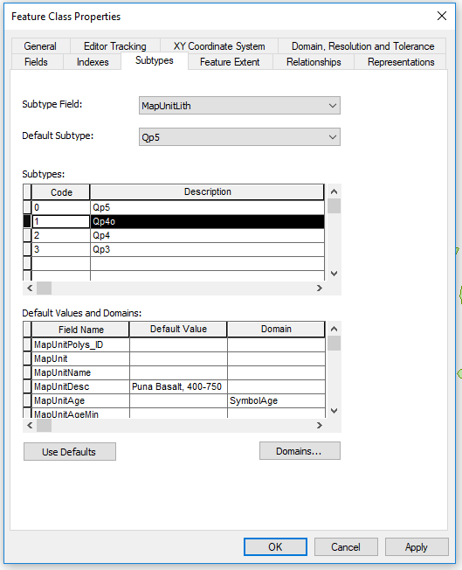

1. On the **ArcCatalog tab**, expand the **GeologicMap** dataset then **right click MapUnitPolys > Properties > Subtypes tab**.
2. On the **Subtype Field**, select **MapUnitLith** from the drop-down menu.

Subtype fields must be long- or short-integer fields; these are the only field types that will appear as options in the dropdown menu.

1. In the **Subtypes box** of the window, in the **Code** column, type ascending integers 0-3 (index numbers) and the pictured unit abbreviations in the **Description** column for each lithology.
2. Click on the row for Code = 0 to highlight it. In the box at the bottom of the window, you may now write **Default Values and Domains** that will correspond with each feature assigned subtype code = 0.
3. One by one, select a row in the **Subtypes table** and copy the bracketed description below into the **Default Value column** of the **MapUnitDesc** field.

* Qp5 = [Puna Basalt, AD 1790 or younger]
* Qp4o = [Puna Basalt, 400-750 yr BP]
* Qp4 = [Puna Basalt, 200-750 yr BP]
* Qp3 = [Puna Basalt, 750-1500 yr BP]

*[Note: These descriptions list the unit name, “Puna Basalt,” as well as the age of the specific lava flow. BP = before present.]*

1. Click **OK** to exit the Feature Class Properties dialog box.

#### Creating Topology Rules for the Dataset

A *topology* is a set of rules and relationships that define how points, lines, and polygons may and may not interact with one another. User-defined rules may be saved in a **topology file** within a geodatabase, and features within that GDB must then adhere to those rules. We can create map topology rules that correspond to rules of geologic mapping. (For example, contacts cannot cross each other, rock units cannot overlap each other…) Establishing these rules before we begin creating features ensures accuracy and agreement in our final map data.

1. In the ArcCatalog tab, **Right click** your **GeologicMap** feature dataset **> New > Topology**.
2. Accept the default name (**GeologicMap_Topology**) and cluster tolerance (**0.001 m**). Click **Next**.
3. **Select All** feature classes to participate in the topology (all 3). Click **Next.** 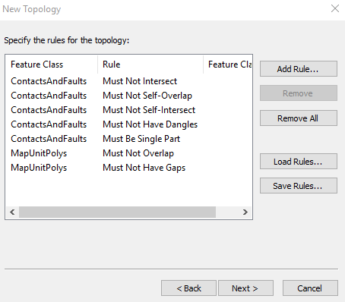
4. Accept the default number of ranks (5) andrank presetof each class (1). Click **Next**.
5. Click “**Add Rule**” to build each of the following seven topology rule statements, clicking **OK** after each rule is created. *[Ask yourself, why might each of these rules be useful later on in a geologic map?]* Then click **Next**.

*Note: We can always add lines that don’t adhere to this topology in a different feature class. For example, one could draw the geometry of a road in* ***CartographicLines*** *or a coastline edge in* ***OtherLines****.*

1. Click **Finish** on the Summary screen. You’ll get a message that the topology was created and that no features were found within the topology extent. Click **OK**, we haven’t created any features yet! Do not validate the topology if asked.
2. Now that your prep in Catalog is done, add the **GeologicMap** dataset to your map document by clicking/dragging **GeologicMap** from theCatalog window into the **ToC**.
3. All the feature classes within **GeologicMap** should automatically expand in the ToC. Collapse **GeologicMap_Topology** for now.

Notice under **ContactsAndFaults**, it reads **Representation: r_ContactsAndFaults_Rep** followed by a long list of numeric codes accompanied by different line symbols. This Esri template uses of **cartographic representations**, where symbology information is stored separately from the feature class itself. Representations allow the creator of the feature class very fine-tune control over symbol appearance, so that the end user (you!) doesn't have to re-create stringent cartographic standards. Each numeric code listed in the Representation file refers to a specific contact, fault, or station type. The webpage shortcut in your **WorkshopData folder, “FGDC Geologic Map Symbol Standard**,” contains the manual defining all of these codes. 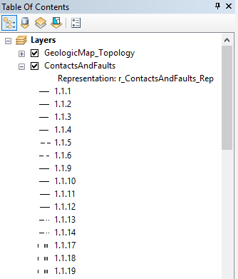

1. Minimize auto-expanded feature classes **ContactsAndFaults** and **OtherLines** for now.
2. Notice that **MapUnitPolys** appears with the preset title **Distribution of Map Units.** In the ToC, you should see entries for each rock unit subtype that you created earlier.
3. Clicking once on the color swatch beside each rock unit will bring up the **Symbol Selector window**. For each rock unit, change the **outline color** to **No Color** and change the **fill color** from the drop-down menu to approximate the following:

* Qp5 = orange
* Qp4o = dark pink
* Qp4 = light tan
* Qp3 = medium brown

1. **SAVE** your map document.

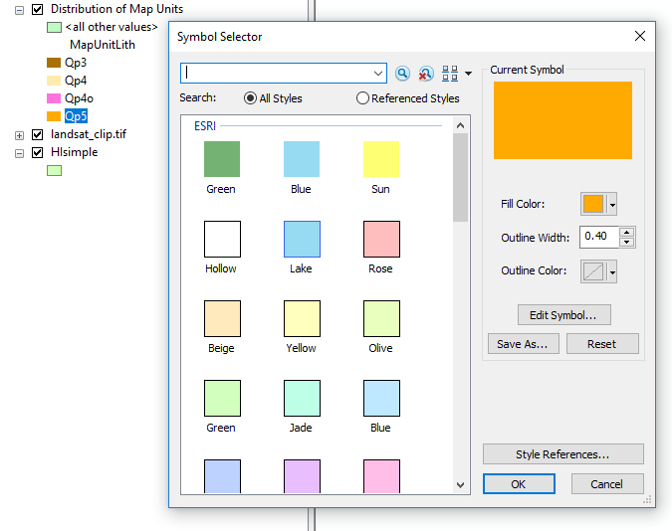

### 3 - ADDING FIELD DATA (XY DATA)

1. From **WorkshopData > Data** in the Catalog window, drag and drop **field_notes.csv** onto your map to add it to your ToC.
2. In the ToC, right click on **field_notes.csv > Open** to view the table’s contents.

Each point contains X and Y information as easting and northing measurements captured by a GPS unit in the field. Some rows contain bedding attitude measurements (strike and dip), others contain only field notes describing geologic features near the point.

1. From the Catalog window, right-click **field_notes.csv > Create Feature Class > From XY Table.**
2. In the dialog box that appears, specify the **X (Easting)** and the **Y (Northing)** fields of your input table. Leave Z as <None>.
3. Click the **Coordinate System of Input Coordinates** button to open the **Spatial Reference Properties** dialog box.

It is critical that the Coordinate System of the Input Coordinates is set to match the coordinate system used by the GPS unit at time of data collection, *even if it differs from the coordinate system you’re currently using in your map document.* The coordinates can always be re-projected later, but for their initial import, ArcMap must know which coordinate system to use to “read” the numbers in the table correctly. In this case, these data were collected using **UTM Zone 5**, which already matches our map’s projection.

This Spatial Reference Properties dialog box doesn’t include the option to quickly choose from a projection used by one of our other Layers, but we can search for the projection we want by name or by the projection’s Well-Known ID (WKID) number.

1. In the “Type here to search” bar, type **26905** (the WKID of our desired projection) and press **Enter**. Click on the one coordinate system that appears, “NAD 1983 UTM Zone 5N”, then click **OK** to close the properties box.
2. Under the **Output** heading of the Create Feature Class window, click the **Browse** (folder) button. Save your output with the name **FieldObservationsHI,** as type “File and Personal Geodatabase feature class” inside of **esriNcgmp.gdb**. Click **Save**.
3. Click **OK** to create the feature class from your XY table.

When we added **field_notes.csv** to our map originally**,** the ToC shifted from “List by Drawing Order” view into “List By Source” view to accommodate the table. 

1. Click the **List by Drawing Order icon** to shift the ToC to its previous view.
2. Expand **esriNcgmp.gdb** in your Catalog window and find your new **FieldObservationsHI** point feature class. Drag and drop the file onto your map document to display it.
3. From the ToC, **right click > Open attribute table** of your new feature class and you will find the same data as in the original .csv.

It may be helpful when drawing rock units later on to see the location of any strike/dip measurements taken in the field, to better visualize the area’s geology. We can label each point based on multiple values in its attribute table--in this case, the strike and dip.

*[Note: This volcanic area wouldn't have rock units with strikes and dips--it's not sedimentary bedding--but I'm making up some measurements just to show how to symbolize them.]*

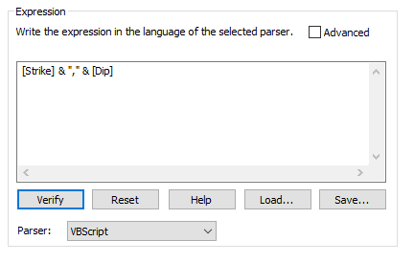

1. In the ToC, **right-click FieldObservationsHI > Properties > Labels tab**.
2. Check **Label features in this layer** and click **Expression.** Delete **[Notes]** from the text box and instead write the VBScript expression ***[Strike] & "," & [Dip].*** Click **OK** to close the **Expression window.**
3. Back in the Layer Properties window, change the **label text size** to **10** and **text color** to **yellow** to make the values easier to see. Click OK.
4. **SAVE** your map document!

Now, each of the points at which you’ve measured a strike and dip displays both values in that order. GPS points without strikes and dips are labeled with pairs of zeroes.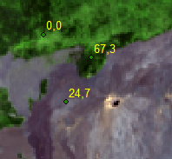

### 4 - DRAW CONTACTS AND FAULTS

#### Add required toolbars and windows to your ArcMap interface

1. Add the **Editor Toolbar** by right-clicking in an empty space at the top of the ArcMap window and checking **Editor** from the list of optional Toolbars that appear**.**
2. Do the same with the **Advanced Editor toolbar**, to use later in the digitizing process.
3. On the **Editor toolbar**, click **Editor > Snapping > Options**, and ensure the **Snap Tolerance** in the dialog box that appears is set to **5 pixels**. Click **OK**.

*Under what circumstances might you want to change the snap tolerance? It depends on the scale at which you are mapping. For smaller scale maps (when you’re digitizing while more zoomed out), you may want to increase the snap tolerance to 10 to compensate for situations where your mouse pointer is farther away from a line than you think it is. But it is mostly a matter of trial, error, and personal preference.*

#### Loading pre-existing geospatial data into template feature classes

We want the rock units we draw to end at our predefined map boundary. If we load a copy of our map border’s geometry into the **ContactsAndFaults** feature class as a line of its own, we can “snap” to it when drawing contacts later without breaking our topology rules.

1. In the **Catalog tab**, inside the **GeologicMap** feature dataset, **right-click** **ContactsAndFaults > Load > Load Data**.
2. Browse to select **MapOutline_shp.shp** from your **WorkshopData > Data** folder as the input dataset, then click **Add** to add it to the **List of source data to load**.
3. Click **Next** through all of the preset wizard pages, then **Finish** the wizard.

You should notice a line appear around the aerial image in your map document--that is your map boundary, now appearing as a feature within the **ContactsAndFaults** feature class!

1. **Open the attribute table** of **ContactsAndFaults** and see that your table now has one feature in it. None of its fields are filled, but that’s OK -- the line is neither a contact nor a fault, and we do not need any geologic information about it. **Close** the attribute table after viewing.

#### Editing Contacts (and digitizing from imagery)

1. Make sure **ContactsAndFaults** is checked (visible) in the ToC. **Right click** the layer **> Edit Features > Start editing!**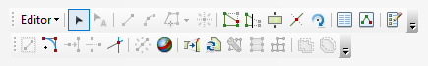

Look at your Editor toolbar now. Because you’ve entered an edit session, the editing tools are no longer grayed out.

1. Click the **Create Features** button on the **Editor toolbar** which opens the **Create Features window**--dock it to the right-side of your ArcMap window.

In the **Create Features window**, a number of possible line types/designs for the **ContactsAndFaults** feature class will appear. These are the same numeric codes from the “FGDC Geologic Map Symbol Standard” guide. For this region of Hawai’i, we will be using the following contact and fault types:

* Contact, certain (**1.1.1**)
* Contact, questionable (**1.1.2**)
* Fault, certain (**2.1.1)**

Start by digitizing a **certain contact (1.1.1)** for the large lava flow that dominates our map area.

1. **In the Create Features window, click** on the contact type you want to draw. Your mouse pointer should now become a crosshair.
2. Find a place in your satellite image where a rock unit contact intersects with your map border and hover your mouse over that location. You should see text pop up as your mouse hovers over the map boundary, reading **ContactsAndFaults: Vertex** or **Edge.** This is the Snapping utility at work!
3. **Click** to place a vertex, so that the start of the contact you’re drawing snaps to the existing map boundary line.

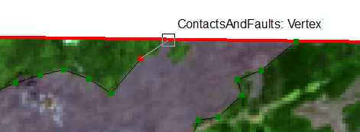

1. Using your image as guidance, continue placing vertices to trace a contact. Keep drawing until you reach another location where the contact intersects with the map boundary, and place your last vertex such that it too snaps to the boundary.
2. You can end your current line by either (a) double-clicking to place the vertex or (b) right-clicking in a space off the vertex and selecting **Finish Sketch**.

#### Making Use of Field Data

Our GPS locations also contain some field notes based on geology we saw on the ground. Referring to these points can be useful when drawing contacts and faults. On our final map, even when we do not symbolize these points intended for our personal reference, we can trust the drawn contact matches the locations we identified in the field.

1. From the ToC, open the attribute table of **FieldObservationsHI**. There are three points that a student took while walking along what they thought was a contact. We can snap the line we draw to these points.
2. In the attribute table, highlight the points with **“contact?”** in the **Notes field** and click **Zoom to selected** ****to instantly see the location of those points on your map (zoom out a bit for clarity).
3. From the **Create Features window**, select the **questionable contact (1.1.2)**, and draw a line that snaps to these three points. Close the questionable contact by connecting it to a certain contact lying to the east.

#### *** Digitizing Tips ***

* Snapping your lines closed is *essential* to properly generating polygons for your rock units later on, so take your time with linework and ensure you are snapping!
* Make sure the lines you make follow the topology that you created earlier (no dangling contacts, etc).
* Faults may cross each other or dangle over contacts, but if the fault acts as a contact, make sure that you draw the lines *snapped* to the contacts around it.
* ArcMap auto-selects the line you just finished drawing and highlights it in bright cyan--regularly hitting the **Clear Selected Features button** helps keep your screen clear.
* If you make a mistake and want to delete the line you’ve drawn so far, **right click** anywhere in the frame and **Delete Sketch**. If you want to delete a single vertex you’ve placed (doesn’t have to be the most recently placed), **right click** the vertex itself and **Delete Vertex**.
* If you want to keep your existing line geometry, but change the line type after the fact:
  + Select the line feature you want to edit. Make sure you are in an edit session.
  + Open the attribute table of **ContactsAndFaults**.
  + Click on the line’s **RuleID cell** in the table and a list of possible line type codes will appear as a drop-down menu. Note that some of the codes are not listed in numeric order.
  + Click to select the new linetype you want to assign, then press **Enter**. Note that no other attributes are updated.
* You don’t have to finish drawing a continuous contact all in one go. You can **right-click** and **Finish Sketch,** then start a new sketch whose first vertex is snapped to the end of the previous line. This is an essential practice, in fact, when a contact becomes concealed or a fault becomes uncertain somewhere along its length; select the new linetype template and begin sketching where your last line left off.
* When mapping an enclosed rock unit, the topology validation will find an error if a single line feature to close on itself. Draw two separate lines to close the loop. Or, use the **Split tool** on the editor toolbar to split your single line into two.
* If it becomes difficult to see the lines you’re drawing, change the opacity/contrast of your basemap image for better visibility.
* Line decorations (e.g. the question marks on your uncertain contact, thrust barbs that indicate a hanging wall) automatically appear on one side of the fault you draw based on the direction you digitize the line. To switch the line directionality (rendering the question marks all in the same orientation):
  + **Double-click** the line. You should see each vertex highlighted as a green square and the “end” of the line highlighted in red.
  + **Right-click** on the line highlighted in this fashion and select **Flip**. You should see the ornamentation change sides and the red “end” vertex on the opposite tip of the line.
* **Save your edits early and often as you work!!!** Saving data edits is distinct from saving changes to your map document. Click on the drop-down menu of the **Editor toolbar** and click **Save edits**. To save your map document, click the **floppy disk icon** in the top-left of the ArcMap window.

#### Editing Faults (and relying on existing geospatial data)

Digitizing fault lines works in much the same way as digitizing contacts. But where to draw the faults? It can be difficult to determine from an aerial photo alone. Before creating a geologic map, you might obtain spatial data from other sources that represent faults and contacts. Let’s load some existing data (faults digitized from a 1996 USGS geologic map) into our template feature dataset, and edit it slightly to adhere to our topology.

1. In the **Create Features window**, select the fault type you want to draw. Let’s start with a **certain fault (2.1.1).**
2. Open your **FieldObservationsHI** attribute table again and **highlight** the points that a student placed while walking along a fault and click **Zoom to Selected** 
3. Draw a **certain fault** that snaps to these points. Do not connect the fault to any contacts.
4. In the Catalog tab, inside **esriNcgmp.gdb > GeologicMap**, right click **ContactsAndFaults > Load > Load Data**.
5. Browse to select **known_faults.shp** from your **WorkshopData > Data folder** as the input dataset, then **Add** it to the **List of source data to load**. Click **Next** through all of the preset wizard pages, then **Finish** the wizard.

Three faults should now appear on your map symbolized in the same “style” as your map boundary (thick red line),because the line Type is unspecified within **ContactsAndFaults**. We can edit the faults’ attributes manually in our table.

1. Open the **ContactsAndFaults** attribute table and scroll to the last three rows that were added (the new “known” faults).

Many of the fields for these rows should read **“<Null>”** because we imported only the fault geometry into our template. You should still be in an edit session (if not, start one), which means you can edit the content of these cells. We know these last three rows are **certain faults (2.1.1)**.

1. Click on the **<Null> cell** in the **RuleID column** for each of your known faults. A list of possible line type codes will appear via a drop-down menu. Select **2.1.1.** to indicate that line is a certain fault.
2. Change the **Exposed or Concealed?** cell values to **No** and both **Existence** and **Identity Confidence** to **“Standard Confidence.”**

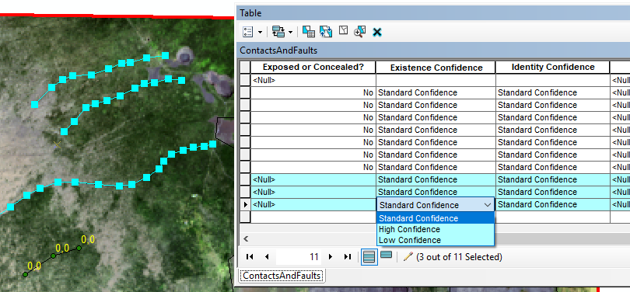

1. Using the **Edit Vertices tools ** in the **Editor toolbar**, move and/or delete vertices on the longest fault you imported so that the ends of it snap to the closest contact *and* do not extend past our map boundary.
2. **SAVE** your edits and **Stop Editing**.

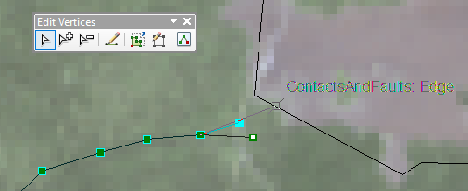

*Note: When importing spatial data from other sources for use in your map, it’s important to keep track of where each piece of spatial information comes from. Feature classes within the* ***GeologicMap feature dataset*** *contain* ***Data Source fields*** *in their attribute tables, where one may add citation information for each point, line, or polygon. We’ll skip this functionality in this workshop, but if you wished, you could add a citation for the map or publication from which you took these fault locations in the* ***Data Source field*** *of the* ***ContactsAndFaults*** *attributes.*

### 5 - SYMBOLIZING AND LABELING ORIENTATION / BEDDING MEASUREMENTS

1. From the **ArcCatalog tab**, add the **OrientationDataPoints** feature class (inside the **StationData** feature dataset) to your table of contents. Collapse the feature class in your ToC when it auto-expands.

We can change the symbology for the **OrientationDataPoints** feature class to enable the auto-rotation of the strike/dip symbol based on strike angle. After changing the *cartographic representation properties* of the empty feature class **OrientationDataPoints**, we’ll load strike/dip measurement locations into this template.

*[Note: Again, this volcanic area wouldn't have rock units with strikes and dips--it's not sedimentary bedding--but practice the symbology with these hypothetical measurements.]*

1. In the ToC, **right click OrientationDataPoints > Properties > Symbology tab**. Ensure you’re showing the options for “representation stored in the layer’s data source.”

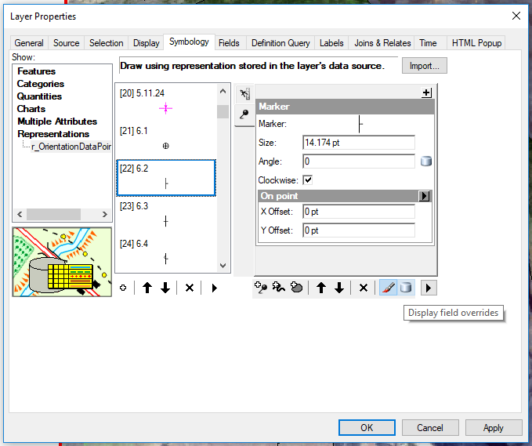

1. Scroll down to select the options for Representation **6.2** (a standard strike/dip symbol).
2. Check the **Clockwise** box in the **Marker settings** on the right-hand side of the Layer Properties window. This means that symbols will be rotated clockwise according to the values provided, preserving the right-hand rule used when measuring strikes in the field.
3. **Click** on the blue cylinder at the bottom right labeled **Display field overrides**. Set the **Angle** attribute to **Azimuth**.
4. Click **OK** to close the **Layer Properties window**. If you receive a warning that the changes to your representation will be saved to the geodatabase, click **OK** to continue.

#### Customize orientation point labels

Strike symbols are traditionally labeled with the value of the dip measurement on the down-dip side of the symbol. We can edit the label settings such that labels are auto-placed in this fashion.

1. **Right-click** on a blank space in the top of the ArcMap window and enable the **Labeling toolbar**. Check **Use Maplex Label Engine** in the toolbar’s drop-down options.
2. Click **Label Manager** (first icon) on this toolbar, then in the window that appears click to select the **Default label class** for **OrientationDataPoints**. Set the **label field** to **Dip/Plunge** (the field heading in your table).

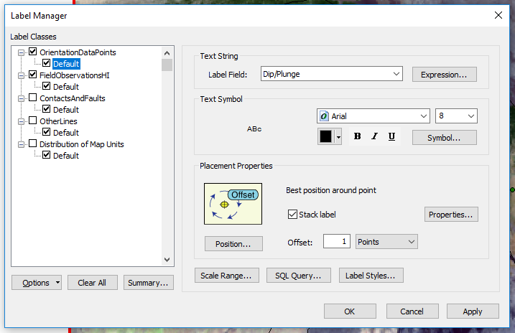

The Esri template we downloaded contains text labels formatted to the FGDC standard stored in a **.style file** that we can import.

1. Click the **Label Styles button**. In the **Label Style Selector window**, click **More Styles > Add…**, then select the **esri-fgdc-maplex.style** file stored in **WorkshopData > StylesAndFonts**. Click Open.

The **Label Style Selector window** should now show various label types (*Fault - displacement, Fold crest, Geophysical boundary*, etc.). You may have to scroll down to see them.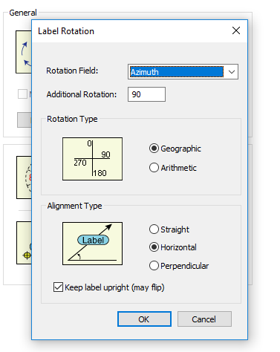

1. Click on the label type **Orientation point - center** to select it, then click OK to apply.
2. Next, back in the **Label Manager window**, click **Properties...** to edit the placement properties of this label. Check the box for **Rotate by Attribute** then click its **Options**.
3. Set thelabel **Rotation Field** to **Azimuth** using **Geographic rotation type** (this should match the format your field measurements were taken in).
4. Change the **Additional Rotation** to **90**, which places the label at the tip of the dip indicator. Click OK, then OK, then OK to close all dialogues.

Now, we’ll load the **FieldObservationsHI** feature class into our **OrientationDataPoints** feature class, so that the strikes/dips can be symbolized according to the defaults we set.

1. From Catalog, **right click OrientationDataPoints** **> Load > Load Data**.
2. Select **FieldObservationsHI** as the input dataset, then **Add** it to the List of source data to load.
3. Click **Next** through the preset wizard pages UNTIL the page where you may set the **Matching Source Field**. Here, identify what attributes in **FieldObservationsHI** you want to be copied into the new attribute titles present in **OrientationDataPoints**. Set the following target-matching fields then click **Next**:

* StationID = Point_id
* Label = Dip
* Azimuth = Strike
* Inclination = Dip
* Notes = Notes
* SymbolRotation = Strike

1. When given the option, choose to **Load only the features that satisfy a query**; this allows you to only add field points that contain strike/dip information.
2. In the Query box on the same page, use the logical expression **Strike <> 0** to select field points that *have* a strike measurement value.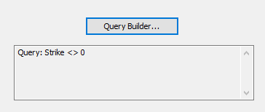

*Note: Depending on what values your data use to signify lack of orientation info, you may have to construct a different query, like* ***Strike IS NOT NULL*** *or* ***Strike <> -999.*** *Zero is sometimes a valid strike measurement, so be careful.*

1. Click through the rest of the wizard then **Finish** the wizard.

Points will appear with their dips labeled, but the strike symbol itself will not appear because the **RuleID** for these new features must be defined first.

1. In the ToC, **right click OrientationDataPoints > Edit Features > Start Editing**.
2. Open the attribute table for **OrientationDataPoints**.
3. Click on each row’s **RuleID** cell and select symbol code **6.2** from the dropdown list.
4. **SAVE** edits then **Stop Editing**.

Your strike/dip symbols should now appear, with the symbols rotated according to their strike angle and the dip value labeled. You may notice that the symbols and dips are very hard to make out in **Data View**; enter **Layout View** to see how the symbols and labels will appear on the final printed map.

#### Add fault ornamentation to show fault movement

The faults in the NW corner of your map are all *normal faults*, with upthrown blocks lying to the north and downthrown blocks lying to the south. How can we illustrate this on our map? You can manually add slip arrows or upthrown/downthrown block notation to your fault line by placing a cartographic representation of that symbol in a location of your choosing.

1. In the **Catalog window**, find **esriNcgmp.gdb > AddOn > ObservationsFaults** and add that empty feature class to your map document. You should see a number of possible fault decoration symbols appear in the **Table of Contents** on the left; collapse the layer for now.
2. In the ToC, right click **ObservationsFaults > Edit Features > Start Editing**. Ensure **Snapping** is turned on. Ensure the **Create Features window** is visible. You may have to scroll down within the window to find the **ObservationsFaults** templates.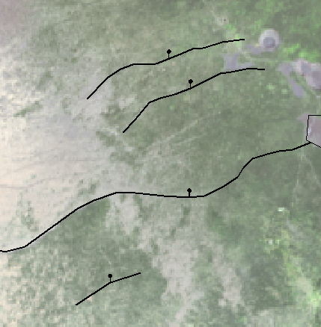
3. Choose fault decoration **2.11.1** from the **Create Features** list. Click once on the center of each fault to place the decoration such that it snaps to the fault line. (Place four total symbols.)
4. **Deselect** the points you just placed (**Clear Selected Features **) so that it is easier to see the symbols. 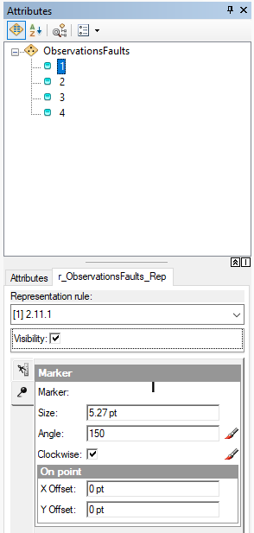
5. Change your map document into **Layout View** mode (if it isn’t already), then **zoom** in to view your four fault decorations clearly.
6. **SAVE** your edits!

The placed decoration automatically orients the bar and ball to the north (see image). But in geologic mapping notation, the ball must fall on the *downthrown* fault block. We must rotate these cartographic representations.

1. In the **Editing toolbar**, click the icon that opens the **Attributes window**.  The Attributes window provides an easy way to edit one attribute at a time.
2. In the **Table of Contents, Right click** on **ObservationsFaults > Selection > Select All**. Now you should see the Object IDs of your four fault decorations appear in the **Attributes window**.
3. Click on the **first Object ID** in your list inside the **Attributes window**. You should see its tabular attributes in the **Attributes tab** in the lower half of this window.
4. Open the second tab in the **Attributes window** (the **r_ObservationsFaults_Rep tab**) to view that point’s Representation options.
5. Add a **marker Angle value** that rotates this bar and ball symbol such that the ball falls on the opposite side of the fault (the south side), but the bar remains perpendicular to the fault, then press **Enter**. You may have to try a few different values manually (i.e. 160 degrees, 190) and see what looks best.
6. To edit the next symbol, click on its **ObjectID** in the **Attributes window** list.
7. Close the **Attributes window** when finished with all four fault decorations.
8. **SAVE** your edits! Then **Stop Editing**.

### 6 - CONSTRUCTING AND LABELING POLYGONS (ROCK UNITS)

We can automatically create our rock unit polygons based on the boundaries of the contact lines we’ve drawn. To ensure we get accurate polygons, it’s essential that we first validate the topology of the **ContactsAndFaults** we’ve drawn, to make sure they follow our rules.

#### Validating map topology

1. Add the **Topology toolbar** to your ArcMap window.

All of the buttons in this toolbar should appear grayed out. In order to run the topology validation tools, you must enter an **Edit Session**; the buttons on the **Topology toolbar** should then be clickable.

1. In the ToC, right-click **ContactsAndFaults > Edit Features > Start Editing.**
2. Switch your map document back to **Data View** and **zoom** so that the entire map area is visible.
3. From the **Editor toolbar**, click **Validate Topology in Current Extent** 
4. If there are any errors in your topology, a red marker will appear on your map image indicating the location of the error. For a closer look at each error, click the **Error Inspector button**  in the **Topology toolbar** and the **Error Inspector window** will appear. (Click **Search Now** if no errors appear in the window immediately.)

Even if your linework is perfect, you should see five point errors that break the rule of “Must Not Have Dangles.” We know these “dangles” lie at the natural end of fault arcs, however, so they are acceptable.

1. **Right-click** on an error from the **Error Inspector window** and select **Mark as Exception**. The red marker locating the error on the map should disappear.

Do you have legitimate topology errors that need fixing? Use the tools on the **Editor toolbar** to snap lines, move vertices, etc. Then click **Validate Topology in Current Extent** again to see whether your edits pass the test.

1. Continue until there are no errors in the **Error Inspector window**, then **close** this window.
2. **SAVE your edits!**

#### Constructing rock unit polygons in MapUnitPolys

1. In the ToC, **right-click** on **ContactsAndFaults > Selection > Make This the Only Selectable Layer**.
2. With the **Select Features mouse** drag a box over your map area to select all your lines in **ContactsAndFaults** (now highlighted in cyan).

The goal is to select all linework to be used as boundaries for the polygons we will construct. In this example it is OK to include faults in this selection: one fault *is acting* as a contact, and three other faults do not create closed shapes and thus will not generate a standalone polygon. If you have a map where faults or other lines create closed shapes and you do NOT want those to be used when constructing polygons, *deselect* those lines before continuing.

1. In the **Advanced Editing toolbar**, click the wrench to **Construct Polygons**. 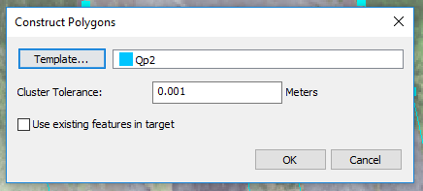
2. In the window that appears, specify the feature class in which these polygons should be created. The **Template** box should be auto-populated with either **one of the subtypes** you created (or simply **Distribution of Map Units** if you did not create subtypes at the beginning). Click the word **Template** if you wish to change the subtype each new polygon will be assigned.
3. Leave the **Cluster Tolerance** at **0.001 meters**. Note this cluster tolerance agrees with the tolerance used when we built **GeologicMap_Topology**.
4. Click **OK**.
5. **SAVE your edits!**
6. Click **Clear selected features** ****to deselect your linework .
7. Open the **attribute table** of **Distribution of Map Units**.

Clicking on a row in the table highlights both the row and the polygon in your map. Click through each feature on the list to ensure no duplicate or erroneous polygons were created, deleting them if necessary.

1. In your attribute table, scroll over to the **Map Unit Lithology Symbol** field. This is the alias assigned to the field **MapUnitLith**, for which we created subtypes.
2. With a row of your table selected (so that you can see which polygon it refers to), click on its cell in the **MapUnitLith** column. Select the code associated with the proper rock unit from the drop-down menu that appears. After assigning a polygon into a subtype, your **MapUnitDesc** field should update for that row as well.
3. Repeat these steps until each of your polygons is assigned the proper lithology type.

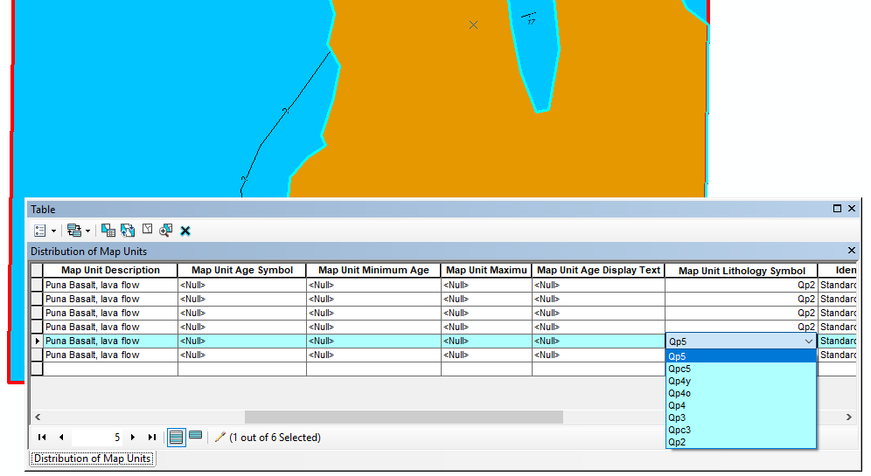

Each constructed polygon was assigned **<Null>** for many other values in the **MapUnitPolys** table template. You may manually edit any polygon attributes that you did not pre-determine with default values in a subtype.

1. **SAVE** your edits!

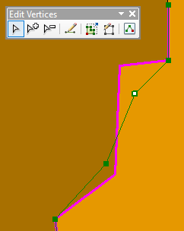

While creating a geologic map you may be constantly adjusting the locations of your contacts and, as a result, the shapes of your rock units. We can edit boundaries while making sure to preserve topology relationships.

1. On the **Topology toolbar**, click the **Topology Edit Tool**. Double click a contact you would like to edit--it should now be highlighted in magenta and vertices should be dark green. A small toolbar called **Edit Vertices** should now appear.
2. Click and drag a vertex to move its location. Utilize tools in the **Edit Vertices** toolbar to add or delete a vertex along your line.
3. To move large sections of the contact/fault, click and drag the magenta line itself. Be careful when doing this, as it can drastically change the location of many of your vertices at once.
4. Double-click off of the selected contact to enact your changes.
5. **SAVE** your edits! Then **STOP editing**.

*Note: As you revise your map, it’s wise to create copies of older editions of* ***MapUnitPolys*** *and save them under a different name. A best practice: before drastically editing* ***MapUnitPolys****,* ***copy*** *the current* ***MapUnitPolys*** *and* ***paste*** *a version within the* ***GeologicMap*** *feature dataset, adding a filename suffix that identifies its version number (ie MapUnitPolys_v3) or the date it was originally created (ie MapUnitPolys_0517). The data connection in your map document should still be tied to the filename* ***MapUnitPolys****, so the document will still visualize the linework from this “working” file.*

### 7 - ADDING MAP ELEMENTS TO LAYOUT

You’ve created your geologic map information--now format it into a presentable figure you could include in a publication!

1. In your ToC**, turn on** the layers that will appear in your final map product and (if necessary) rearrange them in the following order, top to bottom: **ObservationsFaults**, **OrientationDataPoints**, **ContactsAndFaults, MapUnitPolys**.
2. Because the line type of our map boundary is still <Null> in **ContactsAndFaults** it appears as a gaudy, red, “undefined” line. If you wish, enter an **edit session** and change the **RuleID** for your map boundary feature to a *certain contact (1.1.1)* to display it as a simple black line. **Save** your edits, then **stop editing**.
3. Enter ArcMap’s **Layout View**. **Right click** in the top of your ArcMap window and turn on the **Layout toolbar**, if it’s not already on.

You should see your map image in the center of a standard 8.5x11” page, surrounded by a thin black bounding box. This is the ***data frame*** you’ve been working in, automatically titled **Layers**. (This is why everything in your ToC appears under the subheading “Layers”.)

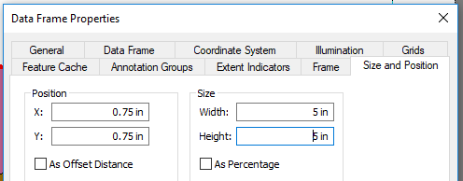

1. **Right click** anywhere on the data frame and choose **Properties**, then go to the **Size and Position tab**. We’d like our final print map to take up 5”x5” in our publication. Change the Size values of the data frame to **Width = 5 in** and **Height = 5 in**. Click **OK**.

Your data frame is now smaller, but some of your map data may have been cut off and no longer appears in the frame. 

1. Use the **Zoom In**, **Zoom Out**, and **Pan** tools on the **Tools toolbar** just like you would in **Data View** to reposition your map data so that it all appears within your 5x5” frame.
2. Use the **Select Elements pointer** to select the data frame itself and drag the 5x5” box to the top left of the page.

Adding a semi-transparent **hillshade layer** to your map gives the viewer an impression of the landscape and may aid in locating landmarks and interpreting geology.

*[Note: This hillshade was built in ArcGIS from a digital elevation model (DEM). A hillshade is just a representation of what that terrain would look like with light cast on it; pixel values do not correspond to true elevation.]*

1. In **WorkshopData > Data** in the **Catalog window**, find **hillshade.lyr** and add it to your **Table of Contents** right above **MapUnitPolys** (make sure it lies under your geology symbols).
2. In the ToC, right click **hillshade.lyr > Properties > Display tab**.
3. Set the **transparency** of the hillshade to **70%.** Click OK.

#### Add Graticule

When viewing a geologic map, it’s helpful to quickly identify the XY coordinates of a location. We will add tick-marks on the outside of our data frame that indicate the lines of latitude and longitude within the study area.

1. **Right-click** on the data frame and select **Properties**, then go to the **Grids tab** and click the **New Grid** button. The Grid wizard will appear in a pop-up window.

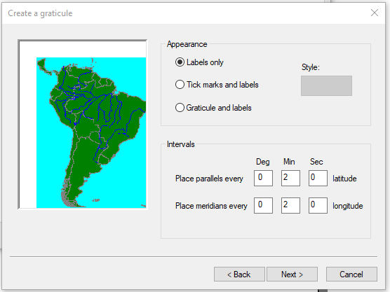

*Ask yourself: What kind of grid do you want to create? A* ***Graticule*** *will create lines based on degree, minute, or second intervals and is often the convention for USGS geologic maps. A* ***Measured Grid*** *will create lines based on meter intervals and is better suited for very large-scale (ie “zoomed in”) areas.*

1. Select the **Graticule** radio button and click **Next**.
2. Select **Labels only** under **Grid Appearance**; we don’t want any lines or crosshairs to appear over top our map content.
3. Set the **Intervals** to place parallels and meridians every **two minutes** latitude and longitude, respectively. Click **Next**.
4. Keep the default Major and Minor division ticks for now. Click **Next**.
5. Keep the Border defaults as is, and make sure that the **Graticule Properties** are **“Stored as a fixed grid that updates with changes to the data frame.”** This means that if you later manipulate what map area is displayed in the data frame, the tick marks will automatically adjust.
6. Click **Finish**.

Back on the **Grids tab** in the data frame’s **Properties window**, you should see the reference grid you just created named **“Graticule”** appear checked in a list. 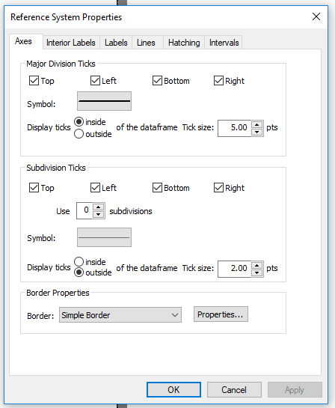

1. Click **Apply** at the bottom of the **Properties window** to view your graticule so far.
2. Select the **Graticule** from the list in the window and click **Properties** to adjust it further.
3. In the **Reference System Properties window,** on the **Axes tab**, choose to display major division ticks **Inside** of the data frame rather than Outside.
4. On the **Labels tab**, check the boxes enabling **Vertical Labels** for the **Left** and **Right** of the dataframe. This will rotate the lat/long labels so they are flush with the sides of the data frame.
5. Click **OK** and **OK** again to close all dialogs.
6. Adjust the position of your dataframe if necessary so the graticule labels remain within the page border.

#### Add Title

1. From the ArcMap **Main Menu**, click **Insert > Title**.
2. In the box that appears, name your map **Geology of the Southern Flank of Kilauea, HI.** Click OK.
3. Double-click on the title that appears in Layout view to open its **Properties window.**
4. Click the **Change Symbol button**. Change the **font size** to **14**. Click OK, then OK.
5. Drag the title so it lies beneath your data frame on the **Layout View** page.

#### Add Scale Bar

1. From the ArcMap **Main Menu**, click **Insert > Scale Bar**.
2. Inside the **Scale Bar Selector window**, choose **Hollow Scale Bar 1** (which closely resembles the standard scale bar in the FGDC guide.) Click **OK**.
3. **Right-click** on your new scale bar in **Layout View** to view its **Properties**.
4. On the **Scale and Units tab**, change the **Division Units** to **Kilometers** and the **Label text** to **“km”**. Click **Apply** and view the changes in the page layout, then **OK**.

There are many other scale bar properties we could change--font size, number of subdivisions, a precise width--but for now we’ll keep the defaults.

1. Click and drag to adjust the width of the scale bar so that it shows **8 km in length**, and center the bar beneath your map title on the page.

#### Add Legend for Unit Names and Symbols

Creating legends in ArcMap can be a little… clunky. For geologic maps, it’s often easier to make two separate legends, one for your rock units and another for your point and linework.   
Let’s start with the map unit legend.

1. From the ArcMap **Main Menu**, click **Insert > Legend**.
2. From the wizard that appears, select what feature classes you want in your **Legend Items list (**right-hand column) using the **“>”** and **“<”** buttons to move the layer names left and right. For this rock unit legend, choose only **Distribution of Map Units**. Click **Next**.
3. Change the **Legend Title** to **“List of Map Units”** and **font** to **Arial size 12, bold**. Click **Next**.
4. Leave the Legend Frame features blank (we don’t want a legend frame). Click **Next**.

The next page of the wizard allows you to change the **symbol patch** of features in your legend. The symbol patch is the size and shape of the swatch of color displayed next to each rock unit of **MapUnitPolys** in the legend. For instance, we could display *ellipses* of color rather than rectangles of color, or display contacts or river lines as S-shaped curves instead of straight lines. We’ll keep the default settings in this example, so click **Next** through this page.

1. Leave the default **Spacing** settings. Click **Finish** to return to the map document.

Your legend should appear on your map layout, but we want to remove the unneeded subheadings and do not want to symbolize rock units that are not present in the map.

1. **Right-click** your map unit legend in your map document and select **Properties**.
2. On the **Items tab**, check the box that reads **“Only show classes that are visible in the current map extent.”** Uncheck **“Show feature count”** and **“Place item(s) in a new column”**, if they are checked. Click **Apply**.
3. Click the **Style…** button beneath the feature class list.
4. From the **Legend Item Selector window**, choose the style **Horizontal Single Symbol Label Only** and click **OK** twice to leave the **Legend Properties window**.

Now we’ll move onto the Symbol Legend.

1. From the ArcMap **Main Menu**, **Insert > Legend** again.
2. From the wizard, select what line types you want in your **Legend Items list (**right-hand column) using the **“>”** and **“<”** buttons to move the layer names left and right. Create a Legend Items list in this order: **ObservationsFaults**, **OrientationDataPoints**, **ContactsAndFaults**. Click **Next**.
3. Change the **Legend Title** to **“Symbols”** and **font** to **Arial size 12, bold**. Click **Next**.
4. Leave the Legend Frame features blank (we don’t want a legend frame). Click **Next**.
5. Leave the default **symbol patch** settings. Click **Next.**
6. Leave the default **Spacing** options. Click **Finish** to return to the map document.

Whoa, your legend looks huge! That’s because it’s symbolizing *every possible symbol type* stored in these feature classes. Let’s remedy this.

1. **Right-click** your symbols legend in your map document and select **Properties**.
2. On the **Items tab**, click the **“Select All” button** to select all feature classes in the legend.
3. Then, check the box that reads **“Only show classes that are visible in the current map extent.”** Uncheck **“Show feature count”** and **“Place item(s) in a new column”**.
4. Click **Apply**.

Your legend should be much more condensed now, only showing lines and symbols relevant to your map. But we can still remove redundant subheadings and only displays (a) our symbol patch and (b) the label stating the line type.

1. On the **Items tab**, after clicking **Select All** again, click the **Style…** button beneath the feature class list.
2. From the **Legend Item Selector window**, choose the style **Horizontal Single Symbol Label Only** and click **OK** twice to leave the **Legend Properties window**.
3. Drag your two completed legends to the right of your map data frame.

Each of your symbols should now only list their FGDC code beside them (since this is how they are labelled in the ESRI template). To change the label to something more useful, edit the label of the cartographic representation directly.

1. From the ToC, open the **Layer Properties** for **ContactsAndFaults**. On the **Symbology tab**, double-click on the current (numeric) label to type in a label of your choice. Re-label your line types according to the following:

* 1.1.1 = Contact, certain
* 1.1.2 = Contact, questionable
* 2.1.1 = Fault, certain

1. Click **OK**. If you receive a warning message saying you’re about to save representation changes directly to the geodatabase, click OK.

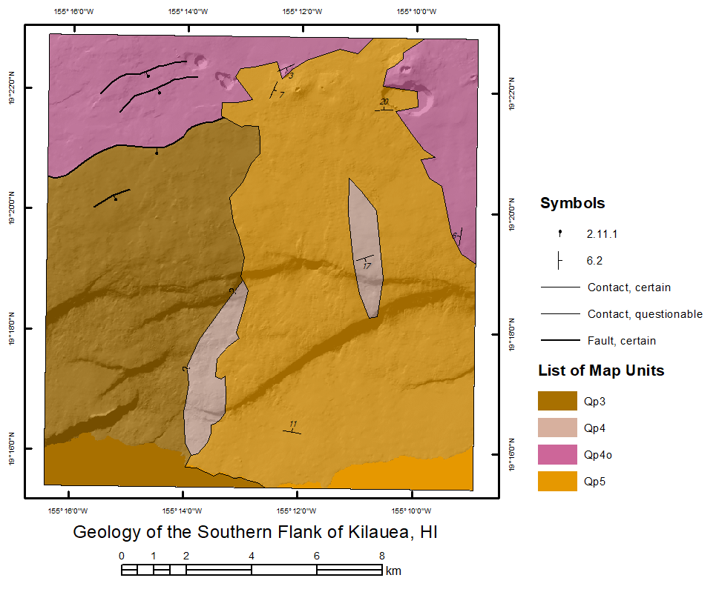

#### North Arrow [add]

#### Inset Map [maybe]

#### Export as a PDF [maybe]